Webinar about Erasmus traineeships in Slovakia for Ukrainians


Dear Erasmus colleague,
I hope this message finds you well.
This time, I am writing you to invite your students to our upcoming webinar about the benefits and opportunities of Erasmus+ internship in Slovakia.
Webinar program:
- What are the advantages of an internship in Slovakia;
- What benifits the free-of-charge Placement Slovakia program brings to you;
- Placement Slovakia internship testimonials of our current and former trainees.
Date:15.11.2023
Time: 4:00 PM CET
Duration: 30 minutes
Platform: Zoom
To secure your spot, please click here to register today for the webinar and get a special bonus by receiving a free guide from the Placement Slovakia team " Unleash Your Potential: Creating a CV to get your dream job ".
We will be more than happy if you can share this Erasmus+ webinar flyer among your students as we believe they might be interesting. If you have any questions or require further information, please do not hesitate to contact us.
Thank you for considering our invitation. We look forward to seeing you and your students at the webinar!
Kind regards,
Placement Slovakia Team
See more opportunities here!

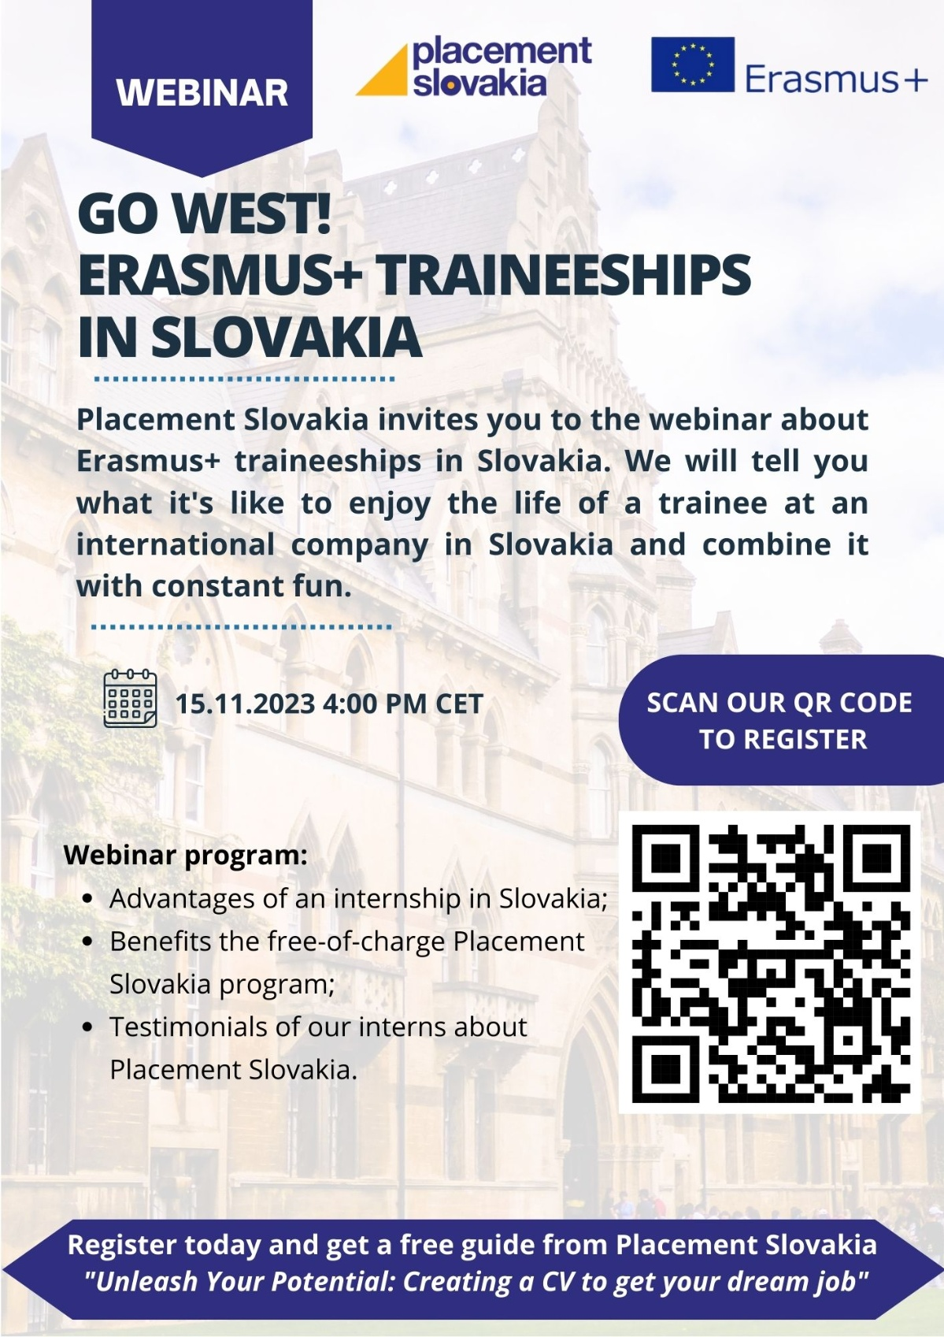







Placement Slovakia Program - WorkSpace Europe
Konventná 636/6, 811 03 Bratislava
E: partners@placementslovakia.com
W: www.placementslovakia.com

odhlásit z odběru těchto e-mailů

