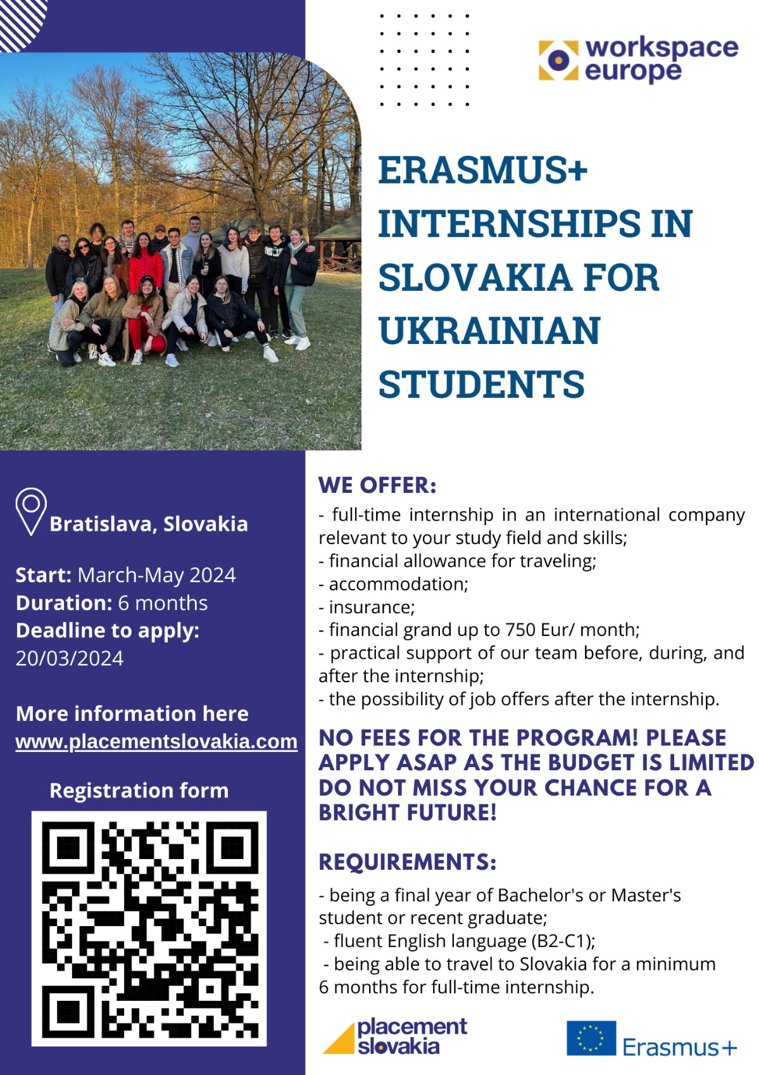







Placement Slovakia Program - WorkSpace Europe
Konventná 636/6, 811 03 Bratislava
E: partners@placementslovakia.com
W: www.placementslovakia.com

